Curriculum information |  |  | 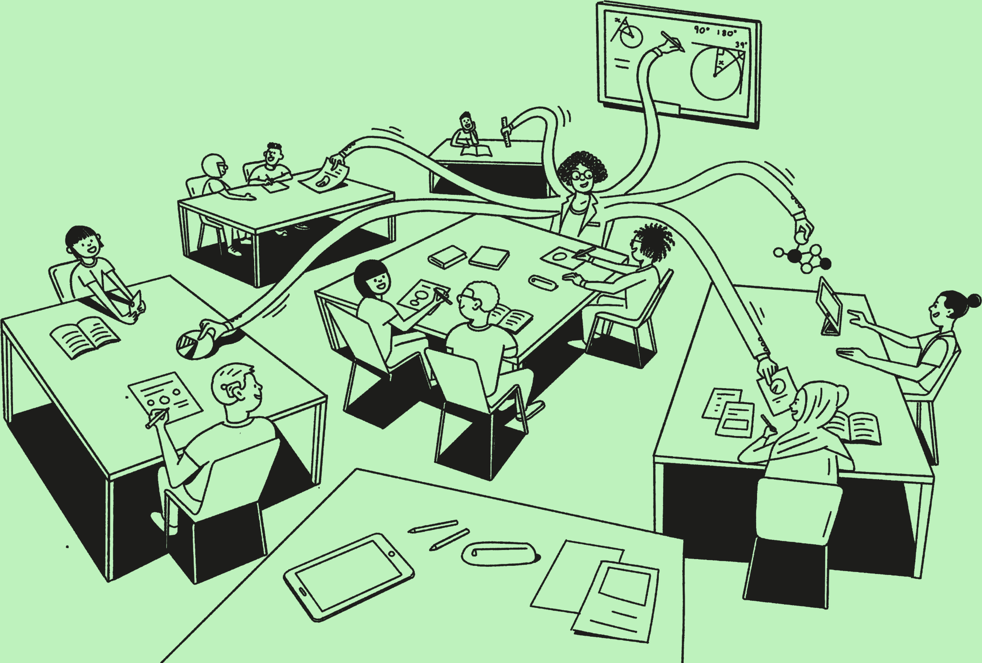
Prior to planning lessons, it is critical to engage with curriculum information. This is the ‘Fit it’ stage of our learning framework. Curriculum information is an umbrella term that describes all of the information that, alongside other lesson components, creates a full curriculum.  All curriculum information is entered and stored in the Curriculum Authoring Tool (CAT). The CAT is a system, built by Oak, to help design curricula and to update and store curriculum information.  During the curriculum development process, your Curriculum Development Leads entered some curriculum information into the Curriculum Authoring Tool (CAT) which you will use to help you develop lessons. |  |  | 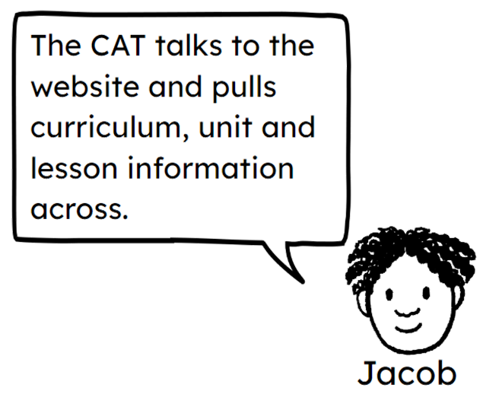

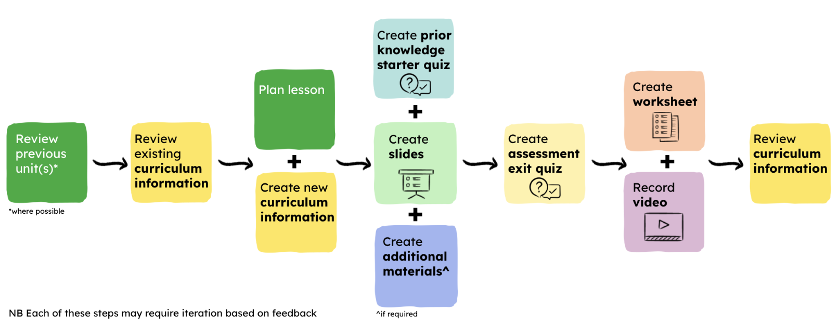

Not all curriculum information can be added until lessons are being created as it is best that curriculum information is entered by the teacher planning the lesson. Given that lessons will develop as components are created, it is likely that this information may also need refining after the lesson has been completed. This is why our lesson creation process suggests reviewing curriculum information before and after lesson components have been developed.

Curriculum information exists at three levels:

Curriculum sequence e.g. thread names, curriculum explainer

Unit e.g. unit name, prior and following unit

Lesson e.g. lesson title, teacher tip
Curriculum sequence |  | This content will need reviewing in the CAT prior to developing lessons.
Item | Description | Action | Further guidance
Curriculum explainer | This will appear on the website and help a teacher picking up an Oak curriculum for the first time to understand its intention and how this manifests in the sequence, threads, units and lessons that have been created. | Pending
Threads | Threads describe the links we develop to achieve coherence and progression across a curriculum. | Review curriculum information | 
Unit title | Each unit will have a unique title, suitable for the age of pupils and supportive for the teacher user. | Review curriculum information
Unit |  | This content will need reviewing in the CAT prior to developing lessons.
Item | Description | Action | Further guidance
Planned number of lessons | This details the number of planned lessons in the unit. | Review curriculum information
Prior knowledge requirements | A list of up to ten bullet points which flag prior knowledge requirements in order to access the learning in the unit. | Review curriculum information
National curriculum content | Use of drop down boxes which detail the specific areas of the national curriculum that have been covered. | Review curriculum information
Exam board content | Use of drop down boxes to indicate which areas of exam board content are covered (where applicable). | Review curriculum information
Threads | Supporting coherence across the curriculum. | Review curriculum information | 
Unit description | A description of the main content within a unit. Used to communicate to users at a glance what the unit contains. | Review curriculum information
Why this, why now | An explanation of why this unit contains the content and why it has been located at this point in the curriculum sequence. | Review curriculum information
Lesson |  | At a lesson level, there is more to do. Some curriculum information needed reviewing but other aspects will need creating and/or iterating.
Item | Description | Action | Further guidance
Lesson title | The title of the individual lessons. | Review curriculum information
Key learning points | These are identified to reflect our knowledge rich curriculum principle.  Each lesson will include up to five key learning points (new knowledge), which are bullet points that list the main content that pupils will learn in the lesson. Some subjects will have these completed, in other subjects they will need to be developed. | Review curriculum information | 
 |  | Create curriculum information
Keywords | These are identified to reflect our knowledge rich curriculum principle. Their accompanying definitions may need to be written. | Review curriculum information | 
 |  | Create curriculum information
Lesson outline | This lists the sections of the learning within the lesson. Each section is known as a learning cycle. | Create curriculum information | 
Lesson outcome | Pupil learning outcomes focus on the ‘takeaway’ from a lesson. They are practical in their intent and focus on the main task(s) which have secured pupils’ learning. | Iterate curriculum information | 
Tags | This field is available if you need to tag an individual lesson within a unit. | Create curriculum information | 
Misconception or common mistake | Inaccurate prior knowledge, or misconceptions, can be a significant barrier to new learning. In identifying likely misconceptions or mistakes at the planning stage, the teacher creator, and the ultimate teacher user will ensure these are kept at the forefront in the planning and delivery of the lesson. | Review curriculum information | 
Misconception response | This directs attention towards the misconception to ensure it remains central to planning and delivery of the lesson in the classroom. This should be written as a single/series of suggested responses and not a script. | Review curriculum information | 
Teacher tip | This is a piece of data that gives suggestions for planning for participation in the lesson - they may be teacher or pupil actions. The teacher tip is most usefully completed after the lesson has been created. In some instances these tips may be generic such as the use of mini whiteboards during CfUs or quizzes or using ‘think-pair-share’ or similar talk structure to promote oracy. | Create curriculum information | 
Content guidance/details/  supervision level | This is an optional piece of data to signpost any sensitive content, potentially offensive content, health and safety, or safeguarding risks related to the lesson. | Create curriculum information | 
Equipment and resources | This is an optional piece of data that is completed for lessons that require additional equipment. | Create curriculum information | 
Copyright content | Third party content has been flagged to ensure we have the required permissions in place. | Review curriculum information | Training in Autumn 2024
Attribution | This is a free text field to store content attribution where applicable. | Create curriculum information | Training in Autumn 2024

